Project Design Phase-II
Data Flow Diagram & User Stories

Date | 6 march 2025
Team ID
Project Name | Visualization Tool for Electric Vehicle Charge and  Range Analysis
Maximum Marks | 4 Marks

Data Flow Diagrams:
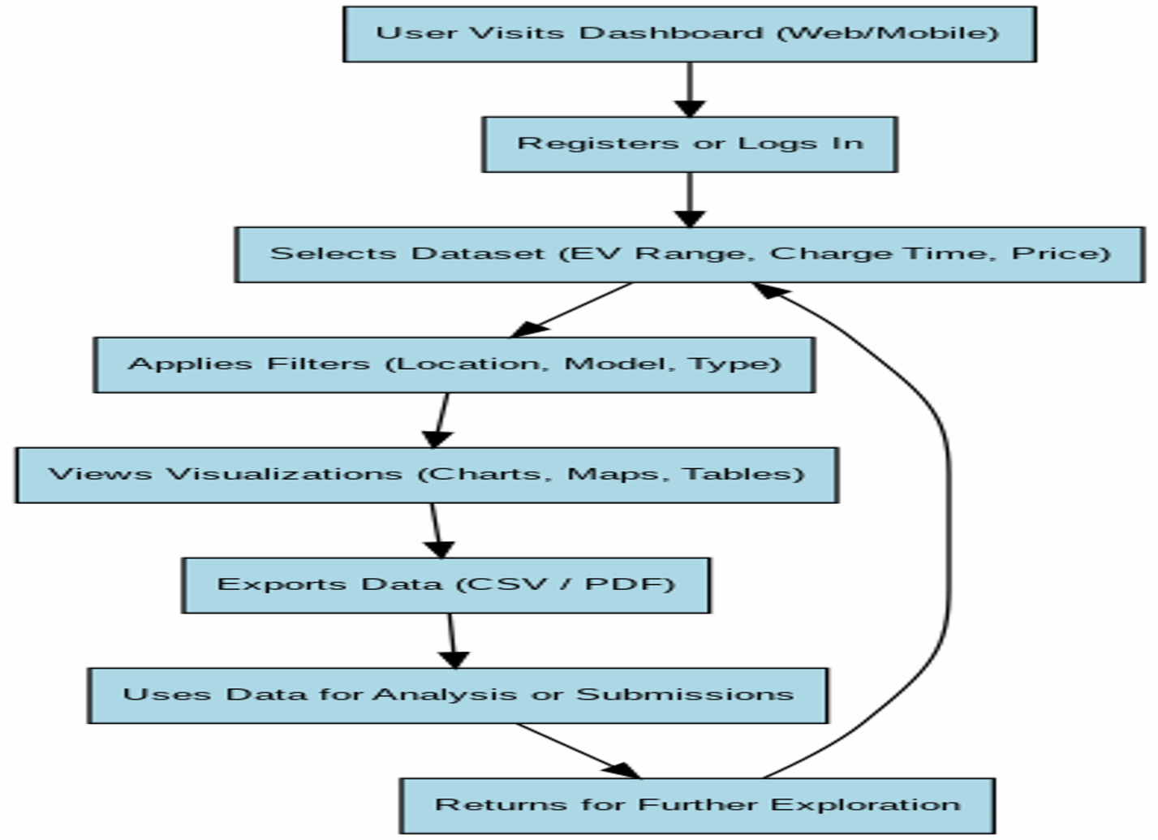

User Stories
